technical Report for EEEM005 Coursework

Name: VASAVI ATKURI
Student ID: 6954763

Overview of the Task and the Solution

The task involves classifying every pixel in a 3000x4000 RGB aerial photograph into one of five land-cover categories: Building (1), Road (2), Tree (3), Vehicle (4), and Grass (5). One labelled training image and its corresponding ground-truth mask are provided for model training, and the trained model is then used to produce predicted masks for two unseen test images. Raw class-label masks were produced as required, alongside colour visualisations for qualitative assessment.
The solution uses a Gaussian Naive Bayes classifier built entirely from scratch with NumPy and the Python math library, with no high-level machine learning frameworks. Each pixel is represented by nine features covering normalised RGB colour, HSV colour-space values, Excess Green Index, a redness-to-greenness ratio, and a local brightness texture measure. Once pixels are classified, a 7x7 majority-vote filter is applied to tidy up noisy predictions and produce cleaner region boundaries.
Looking at the predicted masks visually, the model does a good job of identifying the key regions in both test images. Buildings, roads, vegetation, and vehicles are all picked out in roughly the right locations, suggesting the model generalises reasonably well beyond the training data.

- Detailed Description of the Technical Design
The pipeline consists of three stages that run in sequence: feature extraction, Gaussian Naive Bayes classification, and spatial smoothing.
Feature Extraction.
Rather than feeding raw pixels directly into the classifier, each pixel is first described by a set of nine numerical values. The red, green, and blue channels are normalised to a 0-1 range to keep values consistent. The image is also converted to HSV format, which is useful because the hue channel captures colour in a way that is less affected by changes in lighting. On top of this, two colour ratios are calculated: the Excess Green Index (EGI = 2g - r - b), which tends to be high for vegetated pixels, and a redness-to-greenness ratio that helps tell apart roads and rooftops from greener surfaces. A local texture value is also included, measured as the brightness variation across a 5x5 pixel window, which gives a rough indication of how smooth or rough a surface is.

Gaussian Naive Bayes Classification
During training, the model looks at all the labelled pixels and works out the average and variance of each feature for each class. These statistics describe what a typical building, road, tree, vehicle, or grass pixel looks like in feature space. At test time, each pixel is scored against all five class profiles and assigned to whichever class it fits best. To keep memory usage under control when processing 12-megapixel images, pixels are handled in batches of 200,000.

Spatial Smoothing
After classification, the label map often contains scattered incorrect predictions, especially near class edges. A 7x7 majority-vote filter addresses this by replacing each pixel label with the most common label found among its neighbours. This smoothing step does not require retraining and noticeably improves the visual quality of the output masks. The full pipeline runs as follows: features are extracted from the training image, the classifier fits per-class statistics, and then each test image goes through the same feature extraction, classification, and smoothing steps before the final mask is saved.

- Justification of the Segmentation Model Design

Choice of Algorithm
Gaussian Naive Bayes was selected mainly because it can be built from scratch using only standard numerical libraries, which satisfies the requirement to avoid high-level machine learning packages. It is also fast to train since it only needs one pass through the data to compute class statistics, making it practical for large images. While it makes the simplifying assumption that features are independent, this is often acceptable in practice when the features are well chosen and the classes are reasonably distinct.

Choice of Features
Each feature was included for a specific reason. Raw RGB captures basic colour differences between classes. HSV was added because hue is more consistent under varying light conditions than raw colour values. The Excess Green Index was chosen because vegetation tends to reflect more strongly in the green channel, making it a useful indicator for separating trees and grass from built surfaces. The redness-to-greenness ratio adds extra separation between reddish rooftops or roads and green land cover. The texture measure was included because some classes look similar in colour but have different surface characteristics.

Choice of Hyper-parameters
A small variance smoothing value of 1e-9 was used to avoid numerical errors when a feature has very little spread within a class. The 7x7 smoothing window was chosen through empirical testing — smaller windows left too much speckle noise in the output, while larger ones began to blur fine details such as vehicle outlines and narrow road edges.

- Limitations and Recommendations for Improvement

Overall Performance
The model produces reasonable results on both test images. Roads, grass fields, and building rooftops — which tend to be large and visually consistent — are picked out well, with fairly clean boundaries. The overall structure of each scene is captured correctly, with the main land-cover types appearing in the expected locations. Figures 1 and 2 show the colourised predicted masks for both test images, where each colour represents a different class.

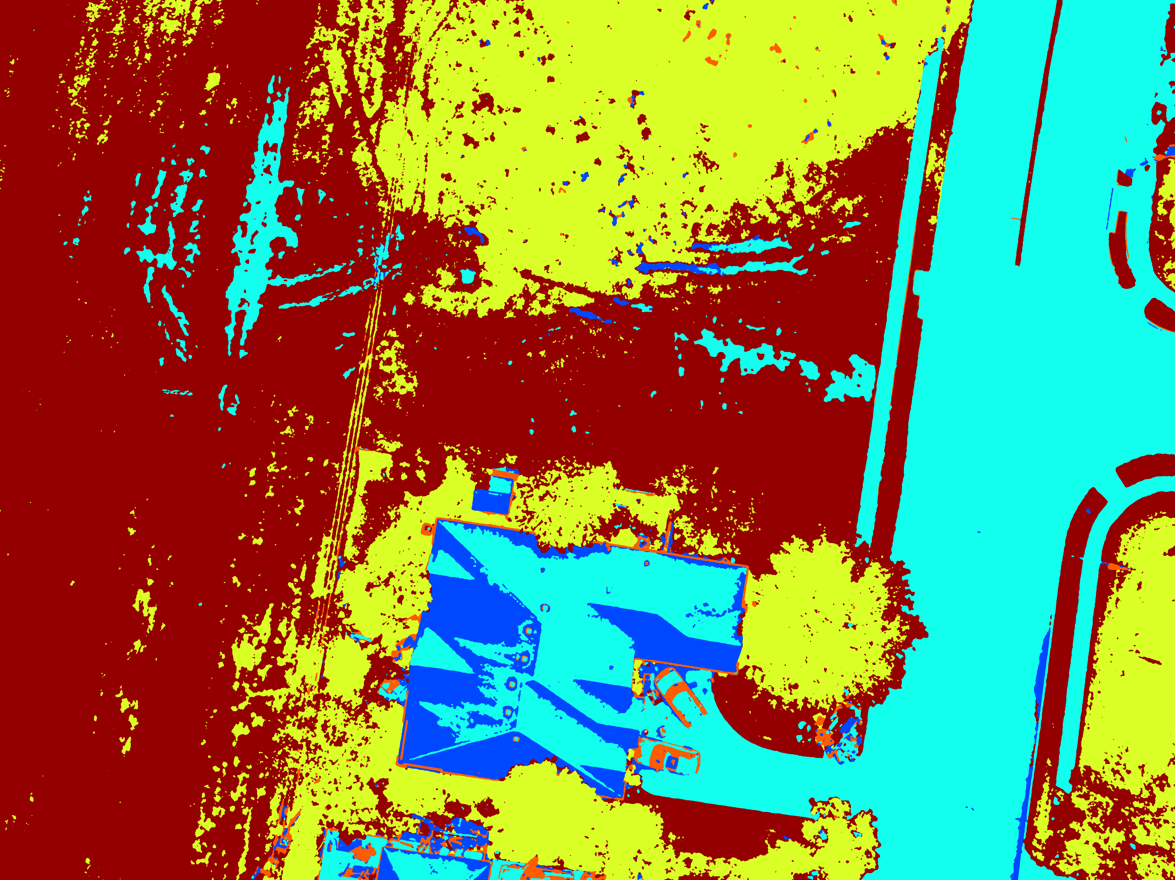
Figure 1: Colour visualised predicted segmentation mask for testing image 1 showing building (blue), road (cyan), tree (dark red), vehicle (orange) and grass (yellow) regions.
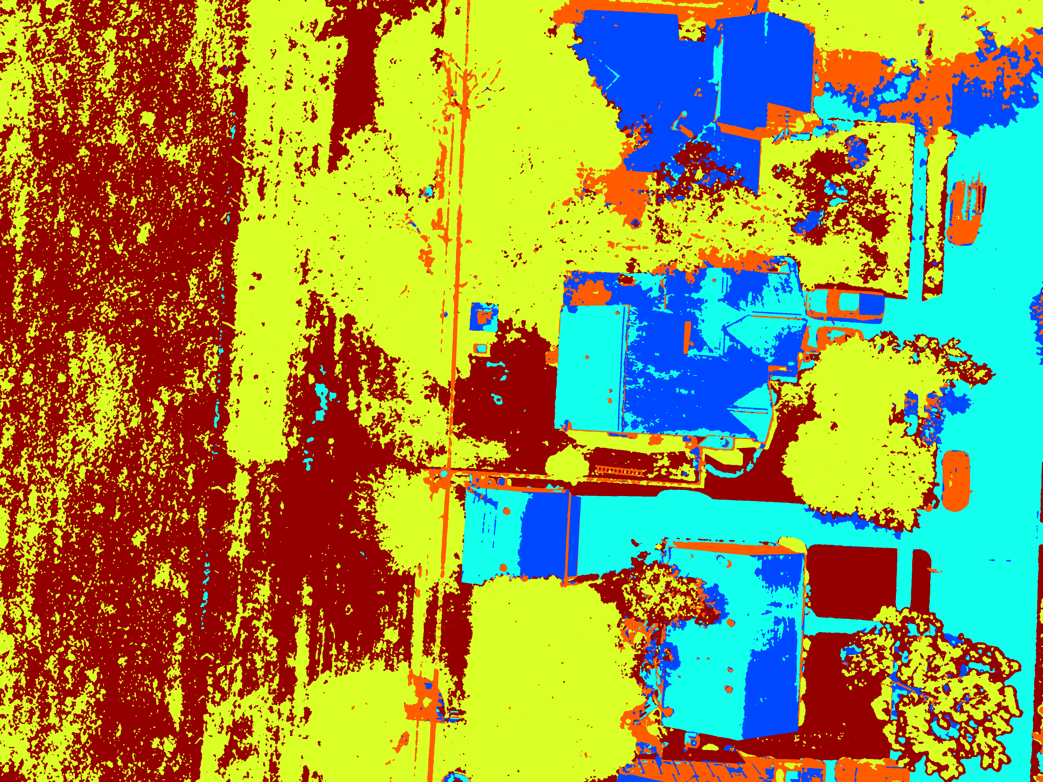
Figure 2: Colour visualised predicted segmentation mask for testing image 2 showing building (blue), road (cyan), tree (dark red), vehicle (orange) and grass (yellow) regions.
The colour visualisations provide qualitative evidence that the model captures the main structural layout of each scene, with distinct and spatially consistent regions for each semantic class.

Where the Model Struggles
The model is less reliable at class boundaries, where pixels pick up mixed signals from two neighbouring regions. Areas in shadow are also problematic — reduced brightness can make vegetated or building pixels look more like roads, leading to misclassification. Vehicles are the hardest class to detect consistently: they are small, vary widely in colour, and can be partially obscured. The independence assumption in Naive Bayes also means the model cannot account for context, so visually similar surfaces like grey roads and grey concrete rooftops can be confused with each other.

Possible Improvements
Including richer texture features such as Local Binary Patterns would help distinguish classes that look alike in colour. Switching to a Multi-Layer Perceptron would let the model capture interactions between features rather than treating them as independent. A Conditional Random Field could replace the majority-vote filter as a more rigorous way of enforcing spatial consistency. Oversampling the vehicle class during training could also help, since vehicles make up only a small fraction of the image and may be underrepresented in the learned statistics.

Disclaimer of AI Use
AI was used as a learning aid to clarify concepts, troubleshoot implementation issues, and review the clarity of writing. The algorithm design, coding implementation, analysis, and final report content are based on my own understanding and work. AI was used only as support, similar to using textbooks or online documentation, and not to complete the coursework on my behalf.

References
[1] OpenCV Documentation. Colour space conversions and image filtering. Available: https://docs.opencv.org
[2] NumPy Documentation. Scientific computing with Python. Available: https://numpy.org/doc
[3] T. Mitchell, Machine Learning. McGraw-Hill, 1997.
[4] R. O. Duda, P. E. Hart, and D. G. Stork, Pattern Classification, 2nd ed. Wiley-Interscience, 2000.
[5] C. Woebbecke, G. Meyer, K. Von Bargen, and D. Mortensen, "Color indices for weed identification under various soil, residue, and lighting conditions," Transactions of the ASAE, vol. 38, no. 1, pp. 259-269, 1995.
[6] R. C. Gonzalez and R. E. Woods, Digital Image Processing, 4th ed. Pearson, 2018.

